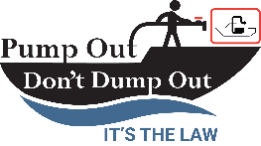
Y-Valve Education Pilot Program

Sample Lease Language

No Discharge Zone and Y-Valve inspection

I understand that Puget Sound and connecting inland waterbodies are within a No Discharge Zone (which means no blackwater or sewage may be discharged into the surrounding water) and agree that marina staff may, at any time, request access to my vessel to inspect my
Y-Valve and Marine Sanitation Device (MSD) using dye tabs and will close and secure (e.g., with a zip tie) the Y-Valve if it is not configured in a closed position.

